**Draw an ERD**

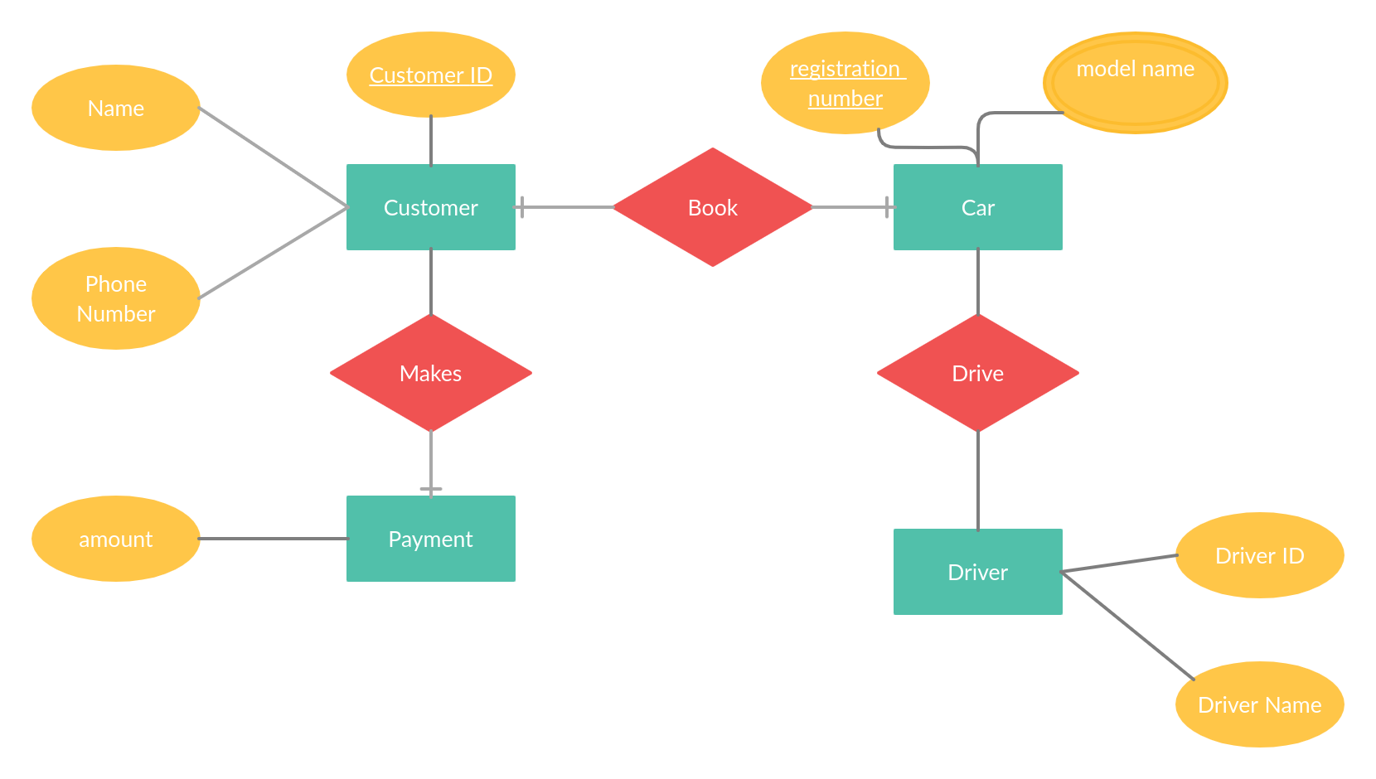

**Relational Schema for the ER**

**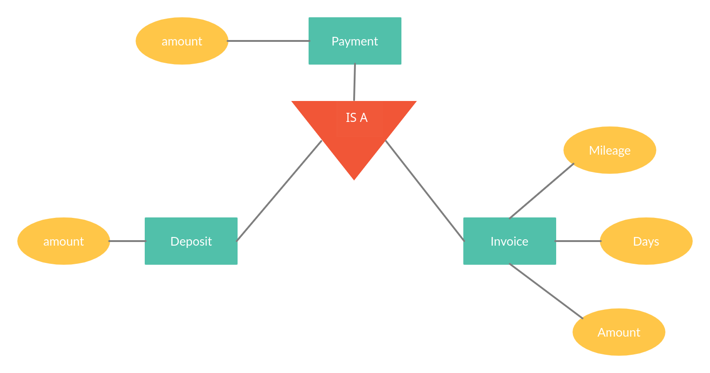**

**Assumptions**

The ERD involves relationships that are mainly one to one

Only the company has a one to many relationship with the cars

**Write an SQL statement to display a list of clients and the registration number of vehicles they hired.**

[SELECT](http://localhost/phpmyadmin/url.php?url=https://dev.mysql.com/doc/refman/5.5/en/select.html) Customers.CustomerName, Vehicles\_Booked.Registration FROM Customers, Vehicles\_Booked WHERE Customers.Customer\_ID = Vehicles\_Booked.CustomerID

**Write an SQL statement to display a list of clients and the registration number of vehicles they hired. This should include those who have not hired.**

[SELECT](http://localhost/phpmyadmin/url.php?url=https://dev.mysql.com/doc/refman/5.5/en/select.html)Customers.CustomerName,Vehicles\_Booked.RegistrationFROMCustomers[LEFT](http://localhost/phpmyadmin/url.php?url=https://dev.mysql.com/doc/refman/5.5/en/string-functions.html" \l "function_left)OUTERJOINVehicles\_BookedONCustomers.Customer\_ID=Vehicles\_Booked.CustomerID

**Write an SQL statement to display a list of clients and the registration number of vehicles they hired and the deposit amount they have already paid.**

SELECTCustomers.CustomerName,Vehicles\_Booked.Registration,Vehicles\_Booked.DepositFROMCustomers,Vehicles\_BookedWHERECustomers.Customer\_ID=Vehicles\_Booked.CustomerID

**Write an SQL statement to display a list of clients and the registration number of vehicles they hired and the cost of hire for vehicles they have hired for more than 3 days.**

[SELECT](http://localhost/phpmyadmin/url.php?url=https://dev.mysql.com/doc/refman/5.5/en/select.html) Customers.CustomerName, Vehicles\_Booked.Registration, Vehicles\_Booked.Deposit \* Vehicles\_Booked.No\_Days As FinalPrice FROM Customers, Vehicles\_Booked WHERE Customers.Customer\_ID = Vehicles\_Booked.CustomerID AND Vehicles\_Booked.No\_Days > 3